5.111: a)
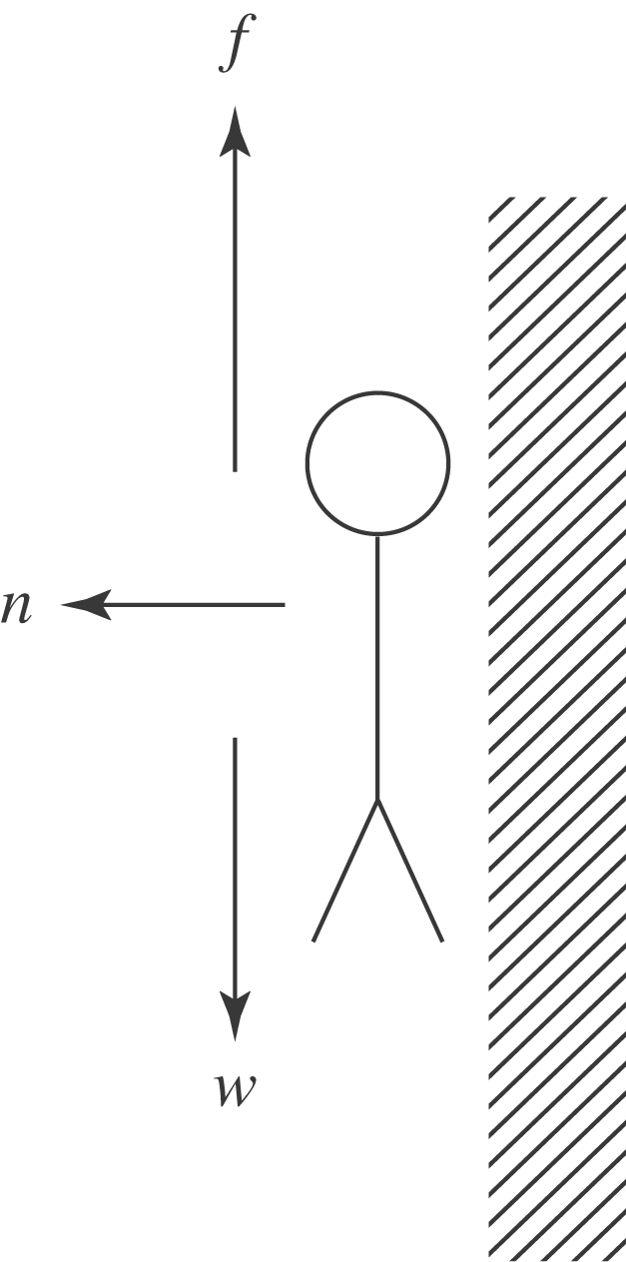

b) The upward friction force must be equal to the weight, so 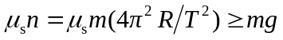 and
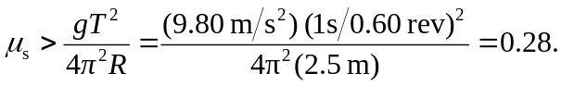
c) No; both the weight and the required normal force are proportional to the rider’s mass.

